TITLE: RFID/NFC BASED ATTENDANCE SYSTEM

ABSTRACT:
This invention describes an RFID/NFC-based attendance system that aims to provide an efficient and cost-effective solution for recording student attendance in educational institutions. The system uses a NodeMCU ESP8266 microcontroller and a PN532 module to read RFID and NFC cards operating at 13.56 MHz. By scanning an RFID or NFC tag, the system instantly updates the attendance data in a Google Sheet, eliminating the need for manual data entry and expensive database setups. The design focuses on accessibility and simplicity, catering to schools that require an affordable and reliable attendance management solution. This system stands out by offering direct integration with Google Sheets, significantly reducing both setup complexity and maintenance costs.

Bharathwaj.K.S Venkata Gowtham Naik N Kalaiarasi.S

FIELD OF INVENTION:
The invention relates to electronic attendance tracking systems, specifically to low-cost, internet-based solutions using RFID and NFC technologies, designed for use in schools and other educational institutions.

BACKGROUND OF THE INVENTION:
Existing RFID attendance solutions on the market are often prohibitively expensive and complex, requiring dedicated database systems and advanced technical infrastructure, which are challenging for schools with limited budgets. This high cost and complexity make these solutions inaccessible for small educational institutions. Schools are seeking simpler, more affordable alternatives that allow easy attendance tracking without significant investment in proprietary software or technical training. The invention aims to address these issues by providing a low-cost, easy-to-use attendance tracking system that leverages RFID/NFC technology and integrates directly with cloud-based Google Sheets for efficient data storage and access.

SUMMARY OF THE INVENTION:
The RFID/NFC-Based Attendance System uses a NodeMCU ESP8266 microcontroller paired with a PN532 module to read RFID and NFC tags at 13.56 MHz. Upon scanning a tag, the system automatically updates attendance records in a pre-configured Google Sheet. The entire setup is cost-effective, requiring minimal technical knowledge to install and operate. It is designed specifically to meet the needs of educational institutions by providing a streamlined, cloud-based solution for attendance management without the need for additional databases or software.
Bharathwaj.K.S Venkata Gowtham Naik N Kalaiarasi.S
SPECIFICATION:
- Microcontroller: NodeMCU ESP8266, which provides Wi-Fi connectivity to enable Google Sheet integration.
- RFID/NFC Module: PN532 module, supporting 13.56 MHz, compatible with both RFID and NFC cards.
- Cloud Storage: Direct integration with Google Sheets, allowing attendance data to be recorded and stored online.
- Low-Cost Solution: Offers an affordable alternative to traditional RFID attendance systems, reducing costs related to software licensing, maintenance, and technical support.
- User-Friendly Design: Minimal setup and simple operation, suitable for schools with limited technical resources.
- Efficiency: Instantly records attendance without manual input, reducing labor costs and errors in attendance records.

DESCRIPTION:
The RFID/NFC-Based Attendance System is composed of a NodeMCU ESP8266 microcontroller that connects to a PN532 module. When a student scans their RFID or NFC card (13.56 MHz frequency), the system reads the unique identifier and transmits it to the Google Sheets API. The attendance record is then automatically updated in real-time within the cloud-based Google Sheet, allowing administrators to easily access and monitor attendance. The device operates over Wi-Fi, ensuring that the data is accessible from any location with internet connectivity. This system is intended for use in schools that require an affordable, reliable, and straightforward attendance management tool.

Bharathwaj.K.S Venkata Gowtham Naik N Kalaiarasi.S
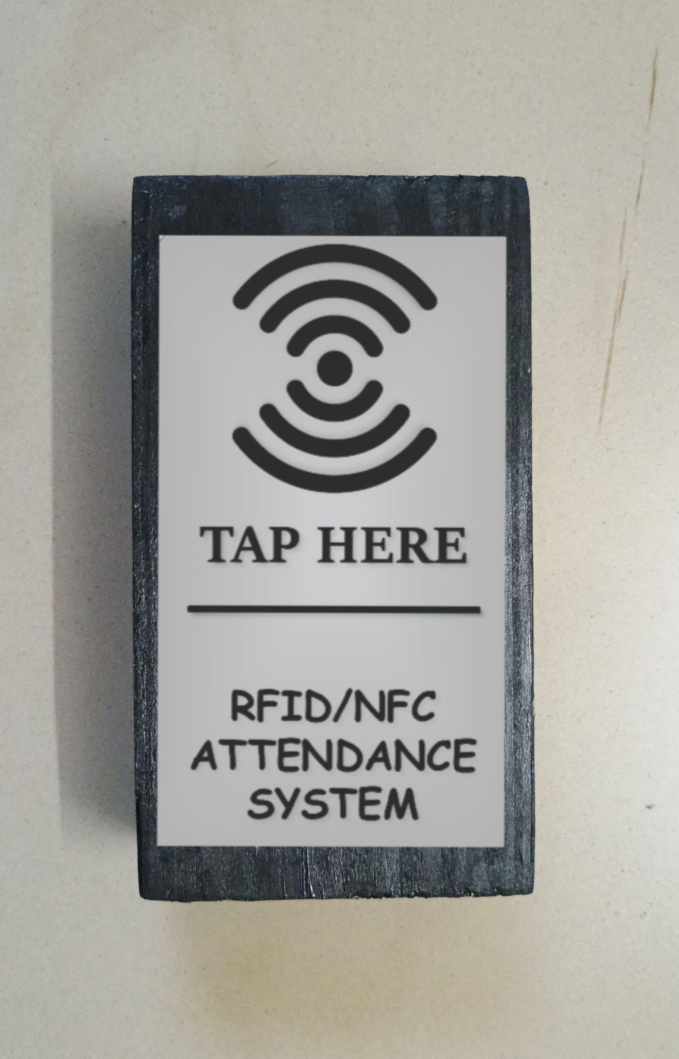 | 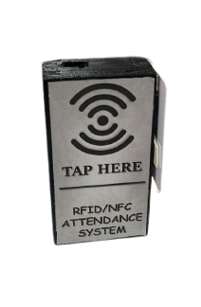

Bharathwaj.K.S Venkata Gowtham Naik N Kalaiarasi.S
WE CLAIM:
- Claim: An RFID/NFC-based attendance system comprising a NodeMCU ESP8266 microcontroller and a PN532 module, designed to read 13.56 MHz RFID and NFC cards for tracking student attendance.
- Claim: A method of recording attendance data in real-time by integrating the system with Google Sheets, eliminating the need for traditional database setups.
- Claim: A low-cost, cloud-based solution tailored to educational institutions, focusing on simplicity and ease of installation without specialized technical expertise.
- Claim: An efficient attendance recording system that minimizes manual labor, offering an accessible and cost-effective alternative for schools with limited budgets.
- Claim: A user-friendly attendance system that uses RFID/NFC technology, providing instant, secure, and accurate recording of attendance data directly in Google Sheets.

Bharathwaj.K.S Venkata Gowtham Naik N Kalaiarasi.S

